Creation of RDS

1. Click on Amazon web Services with your Account. Then we have to select the RDS service.

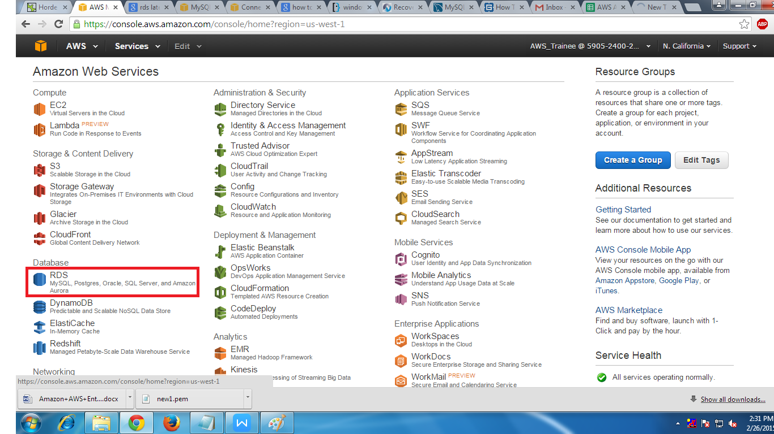

2. Before creating the RDS Instance we have to create the Sub net Group . Click on sub net group .

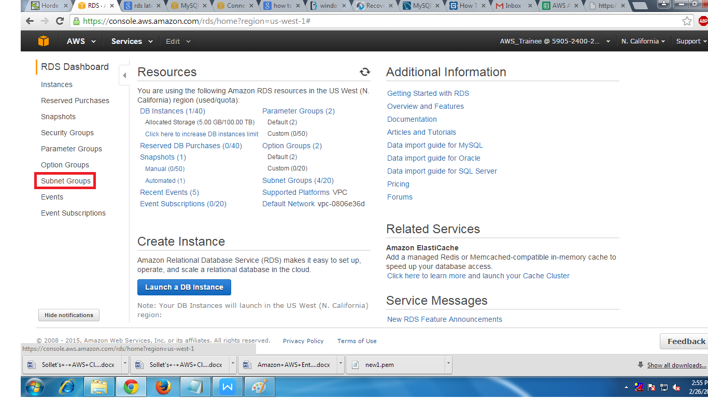

1. Click Create DB sub net Group.

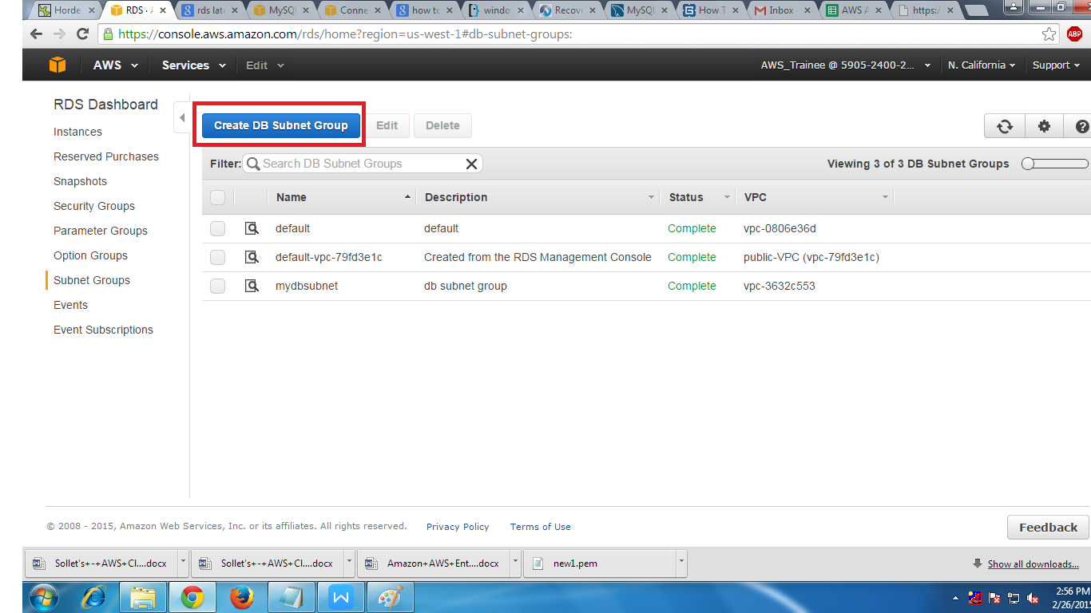

1. Give the following information.

(i) Name (Name of the sub net group)

(ii)Description (Description of sub net group)

(ii)Select custom VPC and add sub nets of different Availability Zones

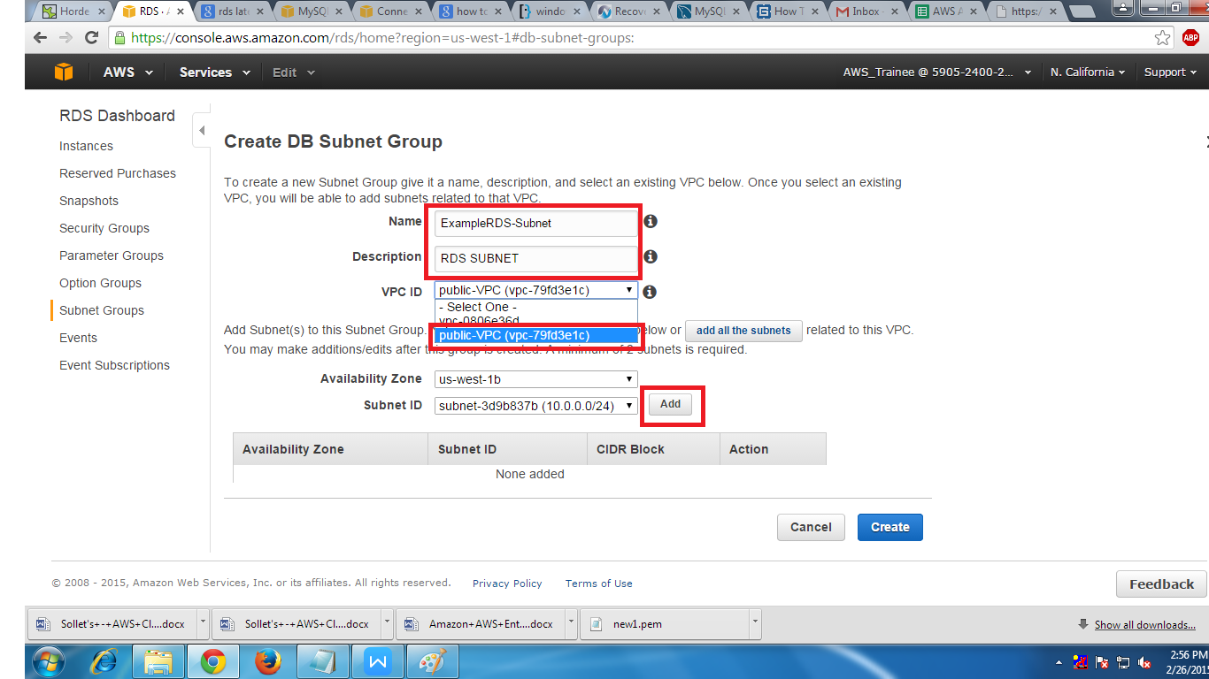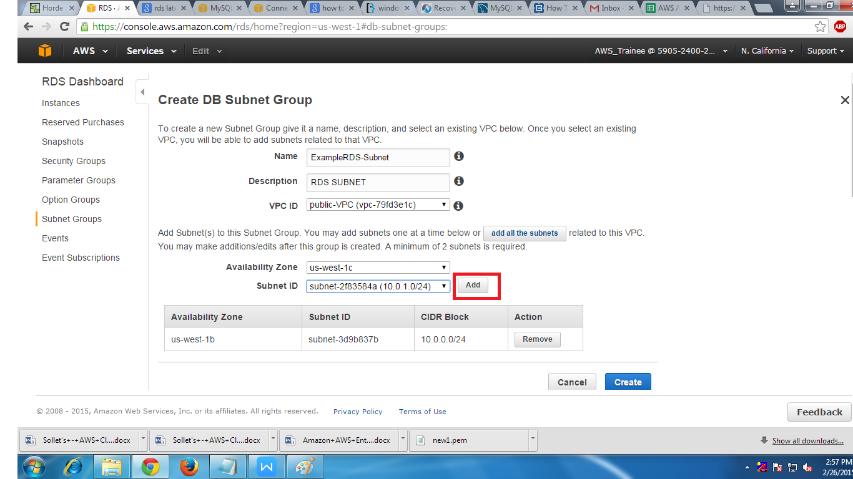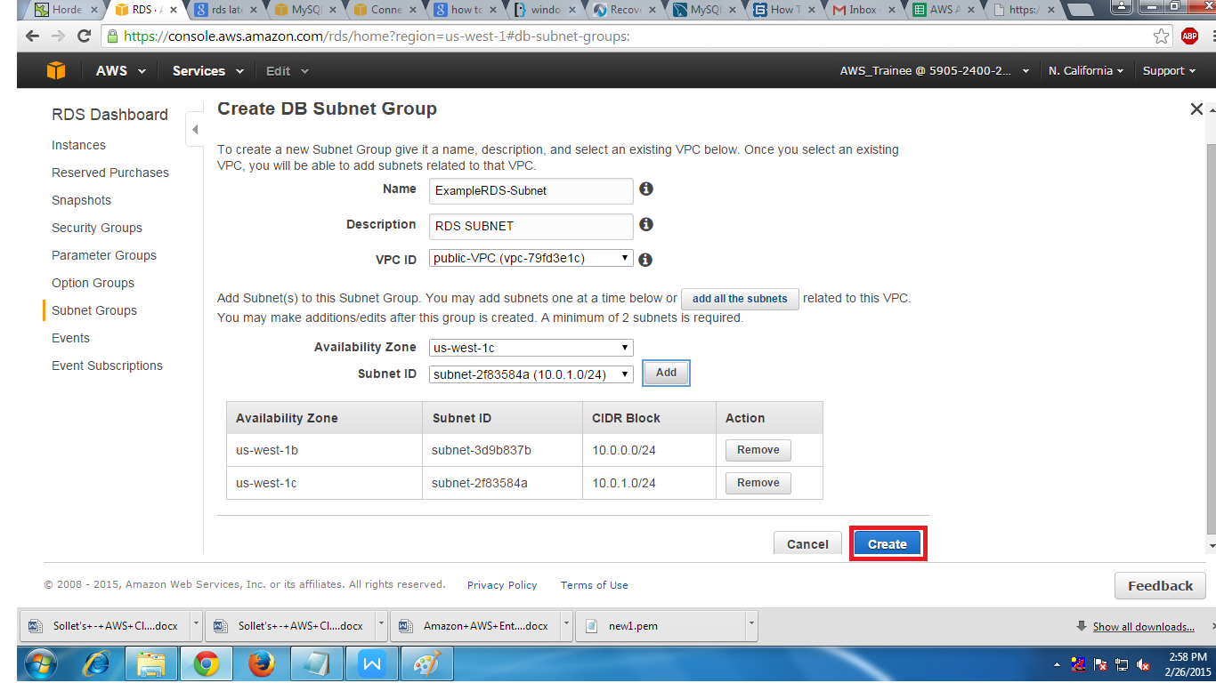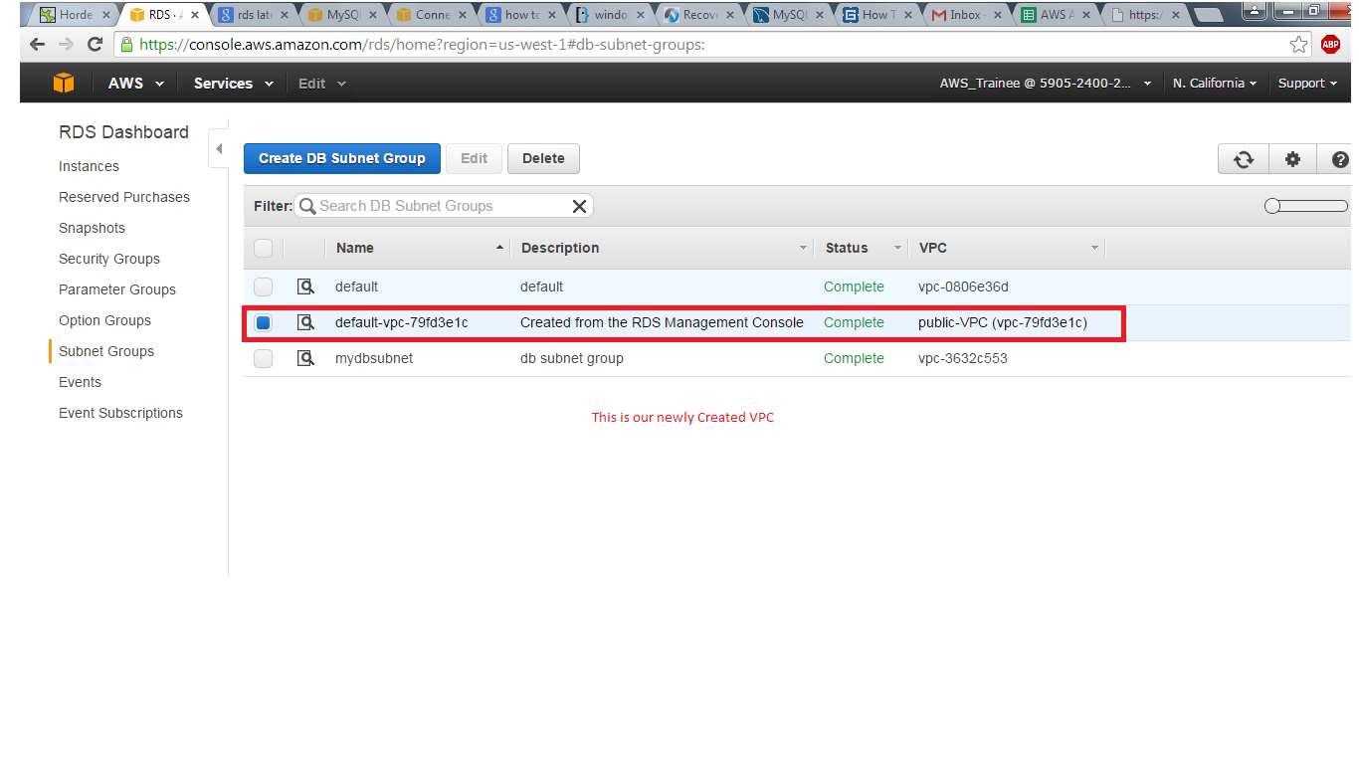

5. After creating the Sub net Group click on Instance in RDS dashboard to create Creating RDS DB Instance

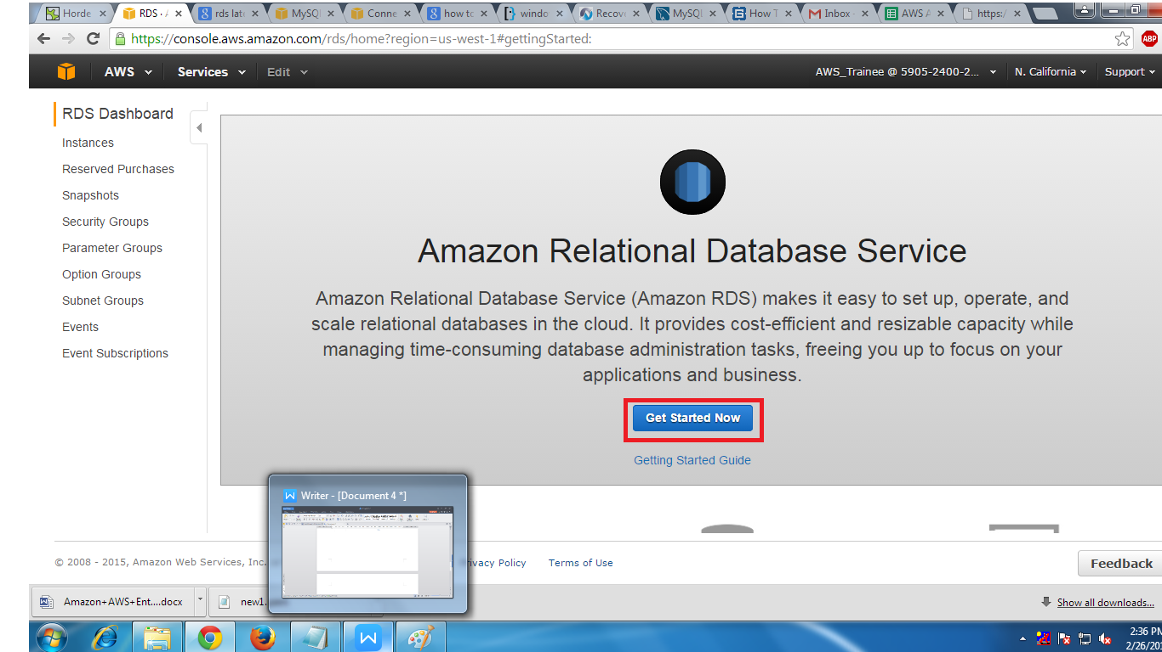

6. Select the DB engine to start the process for example MYSQL

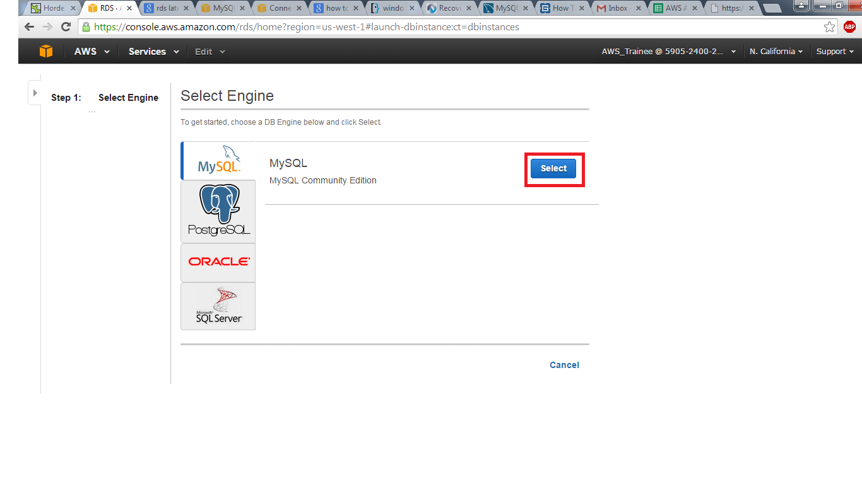

7. If we need Multi Az then check the option YES other wise NO than click on next step.

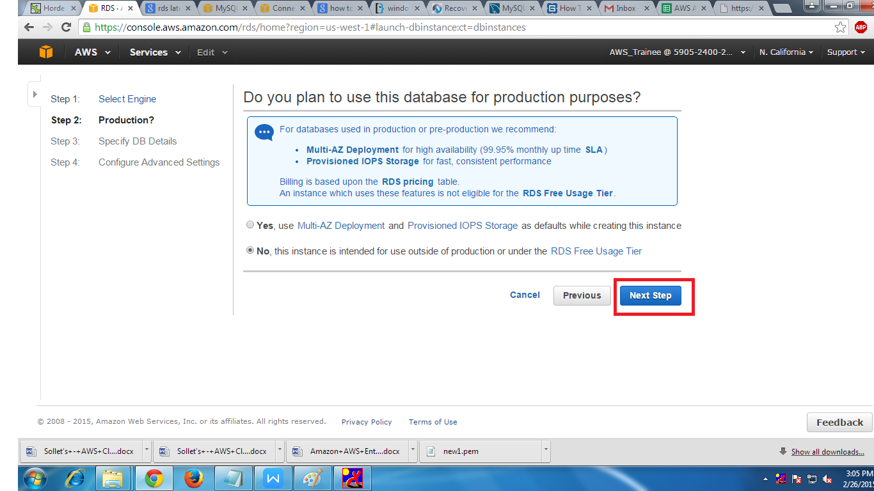

8.We have to give Specify DB Details and select the option YES or No for Multi Az Deployment .After this we have to give the DB Identifier, Master name and Password.

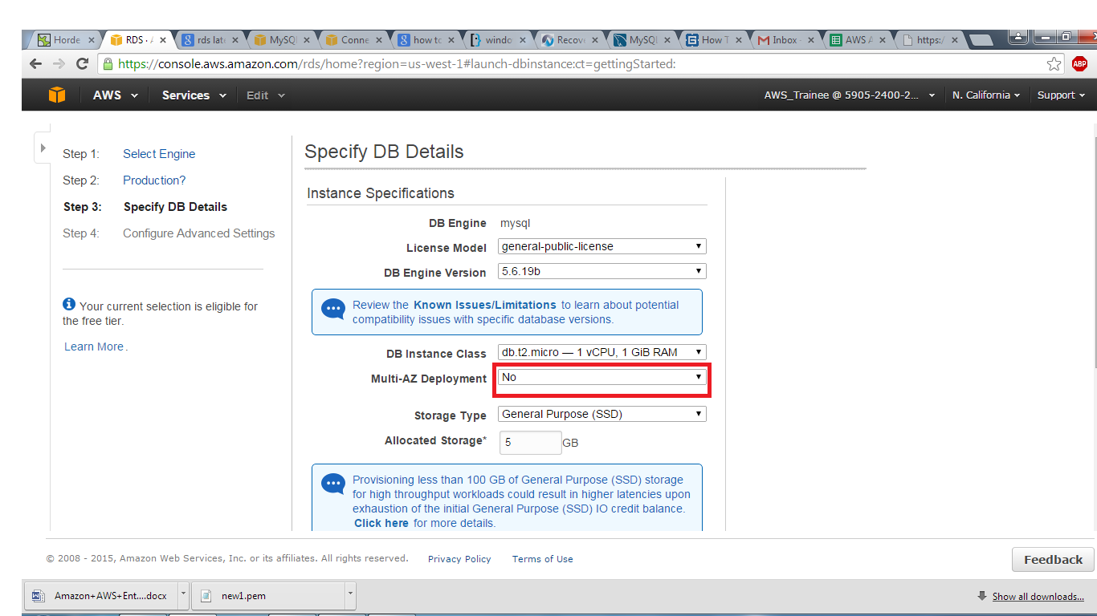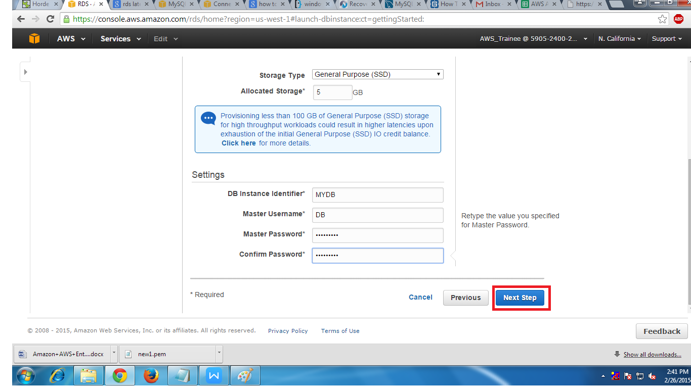

1. Here we have to fill some options like

(i) select customVPC

(ii)select custom public Sub net

(iii)Publicly Accessible to YES

(iv)select custom VPC Security Group

(v) Giving the Data Base name.

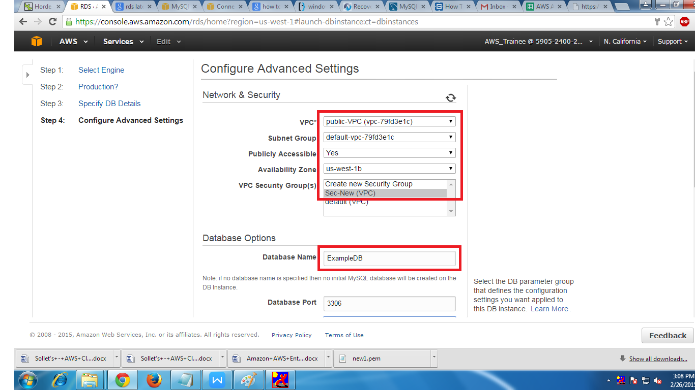

1. At the bottom we have to click on Launch DB Instance.

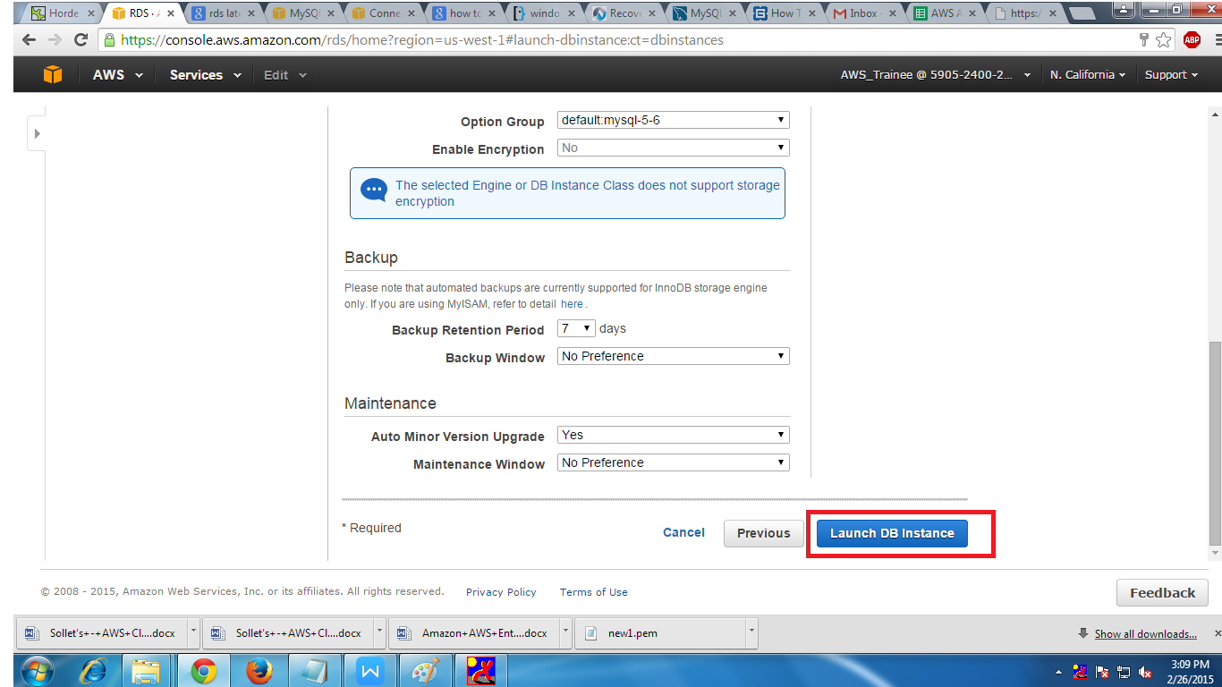

11. At the end we can find that our DB has been created.

